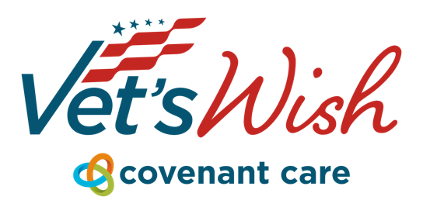
For press inquiries, please contact:
Aaron West
Vice President, Covenant Care Foundation
aaron.west@choosecovenant.org
Mywish.org

Kissimmee, FL – May 12, 2025 – Retired U.S. Army General Jerry L. Neff, U.S. Army, a 2024 Veterans’ Hall of Fame inductee and decorated military and community leader, will fulfill a lifelong dream on May 22nd by taking flight in the legendary P-51 Mustang fighter plane, “Crazy Horse.” The flight is made possible through the Vet’s Wish program, an initiative of the Covenant Care, in collaboration with the Stallion 51 group in Kissimmee, Florida.

A decorated officer with 39 years of military service, General Neff is a lifelong aviation enthusiast. As part of the Vet’s Wish experience, he will not only fly in the World War II-era aircraft but will also take the controls under the supervision of Stallion 51’s experienced pilots.
“We believe every veteran who served our country deserves to be honored — not just for what they did, but for who they are,” said Aaron West, Vice President of the Covenant Care Foundation.
The Vet’s Wish program is dedicated to honoring the service and sacrifice of our military veterans by creating memorable experiences for them and their families. Previous wishes include trips to see the Blue Angels, visiting former military friends, and returning to a place with historical and personal significance. Civic and service organizations can nominate a Veteran by visiting mywish.org/about-vets-wish.
Wishes are funded by a network of generous community donors and fulfilled by the Covenant Care Foundation. 100% of donations are used to make wishes come true and are tax deductible.
Event Details:
What: P-51 Mustang Flight for Ret. General Jerry L. Neff
When: May 22, 2025 | 10:00 AM EST
Where: Kissimmee Gateway Airport – 3951 Merlin Dr, Kissimmee, FL 34741
Who: Ret. General Jerry L. Neff, Covenant Care Foundation, & Stallion 51

